
summative assignment
Hussein Technical University

Abdullah Istanbuli | (21110366)
Special topics Blockchain
Asmaa Lafi

For a table of content press on page number then headings

1.1 Explain the concept of decentralization and its important in the certificate Ledger.

1.1.1 the concept of decentralization
decentralization is the process of distributing power authority and decision making away from a central hub to a network of independent participants “nodes” In this model responsibility is shared the network collectively maintains the system's integrity ensuring that no single entity can fail or manipulate the data without the consensus of the others This concept gained significant traction with the evolution of the internet and the invention of blockchain technology.
The Role of Decentralization in the Internet
Originally the internet was envisioned as a decentralized "peer to peer" network designed for open data sharing and anonymity However as it evolved it shifted toward a multi-layered centralized model (often referred to as Web 2.0) Today vast amounts of global data are controlled by a few dominant organizations and are subject to the regulations and oversight of specific governments This centralization creates single points of failure and allows for censorship or data monopolies.
2. The Role of Decentralization in Blockchain
Blockchain technology reestablishes decentralization by prioritizing security and distributed trust In a blockchain no single administrator has control Instead thousands of servers nodes distributed globally hold an identical copy of the ledger This architecture makes the network nearly impossible to take down or manipulate as changing a single record would require the attacker to compromise the majority of the network simultaneously a feat that is computationally and logistically improbable.

1.1.2 the importance of decentralization in the certificate ledger
Blockchain can play a significant role in Certificate ledger applications where this has many advantageous one of the most obvious advantages is that private entities can bankrupt and be offline in this case a person’s work can go with their databases but if its on the blockchain it cant be taken down, another advantage is for a faster verification of certification because sometimes authentication cant be done online from some educational entities, using blockchain in this case any one can check the certification by opening data related to a identity number and another important aspect is admin proof, having a human in charge of the data is always a risk and removing that from the equation makes it less risky security wise, usually the education institution has control over your record and as we said the blockchain return control to the user where an user doesnt have to ask for permission for a copy of his own record it returns it to the user.
The concept of having blockchain in many industries is better in a lot of cases then using traditional databases as its less cost on an organization but it gives the control to the user, are the companies willing to give up user data?

1.2 Describe how mining works and consensus mechanism (POW and POS).
Mining is the process of verifying transactions and transaction’s data to make sure there is no manipulation and to later add them to the chain of blocks after the block is filled, each coin can be differ in terms of mining process method most of them belong to two categories proof of work / proof of stake the main cryptocurrency that uses proof of work is bitcoin where Ethereum or the correct name ether uses proof of stake method
Mining Proof of work:
First miners chose transactions based on priority which is often related to transactions fees, and then to validate there blook this involve finding a random number called nonce that matches the networks difficulty level targeted when data added of the chain and hashed, when a miner finds the correct nonce they broadcast there block with there own proof of work on the network once it been verified it get added to the chain and the miner moves into the second stage which is receiving the reward, The miner who solved the proof of work is rewarded with newly minted cryptocurrency and transaction fees The reward is generated from the Bitcoin algorithm and is called “Coinbase Reward” The more transaction fees you put, the faster your transaction will be mined and gets approved, the nonce is adjusted every two weeks to maintain coin value and avg mining time.
Proof of Stake (POS):
In Proof of Stake, the process of creating new blocks is called "forging" or "minting" rather than mining. Instead of using powerful hardware to solve math problems, participants are chosen to validate blocks based on the amount of coins they "stake" or lock up in the network. The more coins a person stakes, the higher their chances of being selected to add the next block to the chain.
Validators selection: Unlike POW where everyone competes, in POS the network selects a validator. This selection is often a mix of how many coins you have (your stake) and sometimes how long you have held them. This removes the need for high electricity and expensive GPU or ASIC hardware because there is no race to find a nonce.
Validation and Rewards: Once a validator is chosen, they check the transactions in the block to ensure they are valid. After the block is added to the chain, the validator receives a reward. Usually, in POS systems, there are no "newly minted" coins like the Coinbase Reward in Bitcoin; instead, the reward comes primarily from the transaction fees paid by the users. To keep the system honest, if a validator tries to approve fake transactions, they can lose a portion of their staked coins as a penalty.
Consensus Mechanism Summary:
The main goal of both Proof of Work and Proof of Stake is to reach "Consensus," which means all the computers (nodes) in the network agree on which transactions are real. This is the heart of decentralization because it allows the system to work without a central bank or a boss.
- POW secures the network through physical energy and math, making it very hard to attack because of the cost of electricity.
- POS secures the network through financial skin-in-the-game, making it more energy-efficient and scalable for modern applications like smart contracts

1.3 Compare between PoW and PoS consensus mechanisms. based on speed, power consumption, and enhancing security.
While both Proof of Work and Proof of Stake have the same goal of keeping the ledger safe and decentralized they do it in very different ways Choosing between them usually depends on what the network needs most like if it wants to be the most secure or the most fast Below is a comparison based on the main factors that people look at when they talk about blockchain technology.
Feature | Proof of Work (PoW) | Proof of Stake (PoS)
Transaction Speed | Slower. It takes time for miners to solve the puzzle and for the network to agree. | Faster. Since there is no math race, blocks can be created and verified almost instantly.
Power Consumption | Extremely High. It needs massive amounts of electricity to run the specialized mining hardware. | Extremely Low. It uses about 99% less energy because it only needs basic server hardware to run.
Enhancing Security | Secured by "Physical Work." To attack it, you need to control 51% of the world's mining power (hardware). | Secured by "Economic Stake." To attack it, you need to own 51% of all the coins, and you lose them if you cheat.

In the end, the main trade-off is between "proven security" and "efficiency." PoW is the older method and is considered more "battle-tested" because it has kept Bitcoin safe for over 15 years, but it is very bad for the environment and slow for everyday use. On the other hand, POS is the modern solution that allows the blockchain to scale up and handle thousands of transactions without wasting electricity, which is why most new projects and Ethereum prefer it.
Even though POS is better for things like the Certificate Ledger because it is faster and cheaper, some people still argue that PoW is more decentralized because anyone with a machine can join, while in PoS the people with the most coins have the most power.

1.4 Evaluate the advantages and limitations of decentralization in certificateLedger explain how it improves the integrity, trust, and transparency of the certificateLedger system.
Having a certificate Ledger has both advantages and disadvantages one of the most crucial part of using it is to prevent fraud certification where the owner (the institution ) that published the certificate can be verified and it take away doxing power against a person who have those certificates because no one can has his record unless they share it even though the chain wouldnt be encrypted but in plain text but in a way it increases anonymity, additionally it increases trust and transparency where any one can ask for an org id and check their work that cant be deleted the evidence of any manipulation is in the open for anyone to see.
However, having a system that is open and cant be changed also has some downsides that need to be considered.
The "Right to be Forgotten": Because the blockchain is permanent, if a mistake is made or if a person wants to delete their record for privacy reasons, they actually cant. In some places like Europe with GDPR laws, people have the right to have their data deleted, but with a certificate ledger, once the data is on the chain, it stays there forever. This creates a legal and technical problem because the "immutability" we like for security is the same thing that makes it impossible to delete.
Losing the Private Key: In a traditional university system, if you lose your login, you can just click "forgot password" or go to the registrar and show your ID. In a decentralized ledger, the user has the "Private Key" to their wallet where the certificate is. If the user loses this key, they might lose access to their own records forever. There is no "customer support" for the blockchain, so the responsibility is 100% on the person, and most people are not used to that level of risk.
Cost and Scalability: Even though it saves money on admins, every time you add a block or a certificate to a chain like Ethereum, you have to pay "Gas fees." If the network is busy, it can become very expensive for a university to issue thousands of certificates at once. Also, if a ledger gets too big, it becomes slower for everyone to download the data and verify it.
Summary of the Impact:
So, while the certificate ledger is a huge upgrade for stopping fake degrees and making things transparent, it also forces a lot of responsibility on the user. We are moving from a world where we trust "people" (the university staff) to a world where we trust "code," which is safer from hackers but more punishing for regular people who make mistakes with their passwords or keys.

2.1 Explain the Key features make the Ethereum protocol suitable for smart contract development.
The Gas and Fee System As we mentioned, the fee system is a huge deal for smart contracts. In Ethereum, this is called "Gas." Since smart contracts are basically code that runs on everyone's computer in the network, someone could accidentally (or on purpose) write a "forever loop" that never stops and crashes the whole blockchain. The Gas system fixes this because every single line of code costs a small amount of money to run. This means if a contract is too complex or broken, it will eventually run out of Gas and stop automatically. This protects the network from being spammed or frozen by bad code.
The Ethereum Virtual Machine (EVM) The EVM is basically the "brain" or the engine of Ethereum. It is a virtual computer that lives on thousands of nodes across the world. What makes it special is that it is "Turing Complete," which is a fancy way of saying it can run any logic you can think of. While Bitcoin is mostly for sending money back and forth, the EVM allows you to build things like voting systems, games, or banks because it can handle loops, "if" statements, and complex math. Every node runs the exact same code in the EVM, so everyone always agrees on the result.
Solidity Programming Language To talk to the EVM, developers use a special language (Solidity). It was made specifically for Ethereum and it looks a bit like JavaScript or C++, so it is easier for people who already know coding to start building. It allows you to define "State Variables" which stay on the blockchain forever and "Functions" that people can trigger. Because it is built for the blockchain, it has built-in features for handling money (Ether) and security, which you don't find in normal languages like Python.

2.2 Explain how smart contracts are developed and implemented by implementing the CertificationLedger DApp. [screenshot of your code + explanation of the code]
The ledger smart contract was developed using solidity 0.8.0+ and deployed on a local Ethereum network (Ganache) for testing purposes The contract implements a decentralized certificate issuance system for universities
The contract starts by defining the fundamental variables to store information for the application
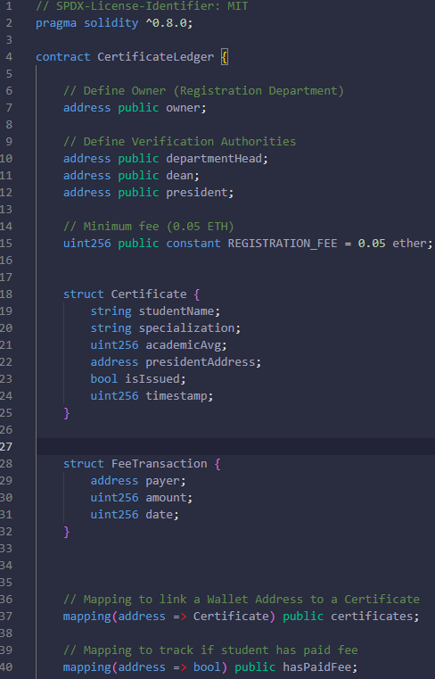
The owner variable stores the address of the wallet of the owner for functions that can only be used by the owner
Registration_fee variable is to define the amount that needs to be paid for certification
Certificate is there to save each certificate information
and feetransaction is there to save info about the payment and student
under it is the mapping to link wallet address to certificate and to make sure that student has paid
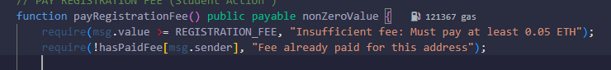
Here is the payable function to enable the contract to accept ETH deposits
Input validation in this function works by checking if the paid amount is 0.05 ETH is received and has Boolean to prevent double spending
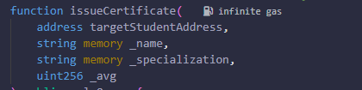
This is the function responsible for issuing the certifications and its only accessible if you have one of the authorized wallets (admins) it stores the wallet address and avg of the student in the database and the name and specialization are temporary until image certificate is lunched
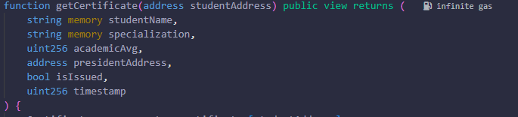
This function retrieves the data when needed its marked as view to not do any modifications to get zero cost function and allow full transparency
2.3 The CertificateLedger should be implemented in a way that detects and handles potential code vulnerabilities. [screenshot of your code + explanation of the code]
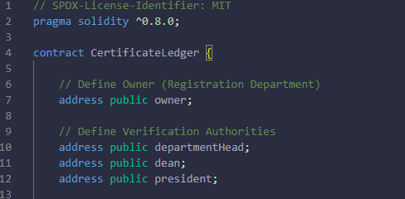
One of the first security vulnerabilities delt with in the code is the access control where some data is strictly accessible only by people with certain wallet id like in our code owner, dean, department head, president any other party cant access private data
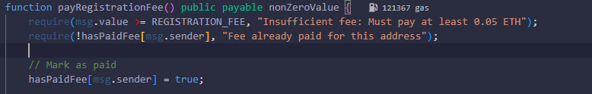
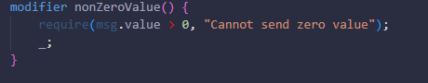
Those two function and modifier act as proof for payment validation where the amount gets validated that its not zero and that it matches the registration fee 0.05

2.4 Assess the impact of using such CertificateLedger DApp in another domain like Conferences or Schools.
Impact on schools
The same principles and benefits of applying the system on certifications apply as well on the educational or schools it provides security from tapering and ensuring school transcripts cannot be accessed by any unauthorized party
The system can provide ease of access from student who want to share there school report cards to anyone who they choose without having to rely on disclosing sensitive information like login credentials or making copies like cave men
Impact on confrences
integrating the certificateledger system into professional conferences enables the simultaneous handling of multiple administrative tasks by using the smart contract logic to automate the collection of registration fees which are recorded permanently on the blockchain while also issuing tamper proof attendance certificates directly to the participants public addresses to prevent fraud and because the platform offers a transparent view of all fee transactions it provides a verifiable record of participation and content information that builds trust among attendees and professional organizations

3.1 Identify three common security threats that could affect a blockchain.
Blockchain is different then other databases where confidentiality is not our main concern in the security of it, it uses a system of data flooding where anyone can see all the data but no one can analyze it or take useful information out of it because of the size of data input so the principle of security changes because of the differences
As cyber security community we all know that if its not offline it can always be hacked so the question becomes what is the most dangerous security flaws in the blockchain system
The 51% attack
In the blockchain world an attack that controls more then 50% of the network’s computing power can tamper modify, exclude transaction what can this lead to ?
revers transactions while in control: in the scenario an attacker has the power to take control of every block being produced so the attacker can easly pay a transaction and never actually put it in the blockchain because mining system is in his pocket
Eclipse attack
This attack can be preformed if the attacker has isolated a specific node of any kind where in a peer to peer network like the blockchain the victim can only communicate with or through the attacker and does have any access to the rest of the network
This can lead to the attacker preventing other miners form learning about new block or an isolated node can make the wrong decision based on fake or false data being fed by the attacker
Classic DoS attack
The most famous attack in the internet is still applicable in the blockchain systems and there are types to the dos attack in blockchain:
Transaction flooding: attackers can send mass packets of low value tranactions to fill the mining pool where this way the attacker prevent or more accurately delays any potential incoming transactions
Resource exhaustion: attackers can target CPUs, memory, bandwidth or disk space by repeating invalid requests and malware that downloads the entire history of the ledger constantly.

3.2 Public blockchains are transparent by design which mean that every transaction is visible to anyone. explain at least two techniques to enhance privacy in blockchain to avoid tracing of past and future transactions.

1. Privacy Challenges in Public Blockchains
One of the major issues in public blockchain technology is transparency On networks like Bitcoin and Ethereum the ledger is open meaning any user can access the history of all transactions made Because wallet addresses can be tracked across multiple transactions if a specific address is linked to a real-world identity a third party can trace that user's entire financial history.
To address this the industry has developed methods to hide data and enhance privacy One prominent example is the use of Ring Signatures a cryptographic technique notably employed by the Monero cryptocurrency While anonymity is sometimes associated with illicit activity privacy remains a legitimate requirement for financial security In a Ring Signature system a group of users appears to sign a transaction together The actual signer is hidden among a set of "decoys" (other users' past transaction outputs) To an outside observer it is computationally impossible to determine which specific group member initiated the transaction This effectively breaks the link between the sender and the transaction.

2. Privacy-Enhancing Techniques

A. Ring Signatures (Cryptographic Privacy)
To address transparency issues, some blockchains use advanced cryptographic methods to hide transaction data. A primary example is Ring Signatures a technique notably used by the Monero cryptocurrency.
In a Ring Signature system a group of users appears to sign a transaction together The actual signer is hidden among a set of "decoys" (other users' outputs) in the ring To an outside observer it is computationally impossible to determine which specific group member actually initiated the transaction This effectively breaks the link between the sender and the transaction ensuring that the origin of the funds remains anonymous.

B. Coin Mixing
Another common technique to enhance privacy is Coin Mixing (often referred to as CoinJoin). This method involves combining transactions from multiple different users into a single large transaction By mixing the funds together before they are sent to their final destinations the direct link between the sender and the recipient is obfuscated.
This technique is often integrated into privacy-focused wallets such as Wasabi Wallet or Samourai Wallet. These tools automate the mixing process making it significantly harder for blockchain analyst to trace the "trail" of a specific coin from point A to point B.

C. Tor Network Integration
While the blockchain ledger reveals transaction data a user’s physical location can also be exposed via their IP address when they broadcast a transaction To prevent this users can integrate their blockchain clients with the Tor Network (The Onion Router).
Tor routes the user's internet traffic through a random series of servers (nodes) around the world before reaching the blockchain network This process masks the user's real IP address and physical location ensuring that even if a transaction is visible on the ledger the geographic origin of the person who sent it remains hidden.

D. Virtual Private Networks
Similar to Tor using a Trusted VPN is a standard best practice for privacy mentioned in the slides A VPN encrypts the user's internet connection and hides their IP address from the internet service provider and the blockchain network This adds a layer of anonymity ensuring that the node receiving the transaction cannot geographically locate the user who broadcast it.

E. Peer-to-Peer (P2P) Exchanges
To enhance privacy users can utilize Peer-to-Peer Exchanges (like Paxful, as mentioned in the slides). These platforms allow individuals to buy and sell cryptocurrency directly with each other without going through a centralized order book that stores their personal data reducing the risk of identity exposure.

F. Off-Chain Transactions (Lightning Network)
Lightning transactions are not immediately broadcast to the entire network. Instead, they occur in a private payment channel between users. Only the final settlement balance is recorded on the public blockchain meaning the individual micro-transactions that occurred in between remain private and invisible to the public ledger.

Conclusion
These techniques collectively address the core privacy challenges of public blockchains by reducing traceability, preventing identity linkage, and limiting metadata exposure while preserving ledger transparency.

3.3 Discuss potential legal and regulatory challenges CertificateLedger might face when using blockchain for issuing certificates.
Yes there might be some legal and regulatory issues with the system of certificates lefger on the blockchain and one of them is that the blockchain is designed to be immutable which means the data will always be there no matter what and according to the GDPR every individual have the right to erase his/her data which means a correct application to apply this regulation is to build in a way that users can delete there address and by doing so there data would have an invalid or null address making it delectable for the user
Another issue we might face in building this system is the transparency of data by designing the system on blockchain the data will be public and we might face issues with exposing sensitive student data which may violate some privacy laws for educational records

3.4 Critically analysis a real-life blockchain security breach. Explain how it happened and propose solutions to mitigate such breach in CertificateLedger.
reentrancy vulnerability is a very dangerous flaw in smart contracts that allows an attacker to drain millions from accounts it happens when a contract interacts with another contract by making an external call but it doesnt handle it properly in a real life breach like the dao hack the attacker used a malicious contract to call a withdraw function repeatedly before the previous call was even finished the bank contract checks the balance and sends the money but because the code is written to update the balance after the money is sent the attacker can trigger the fallback function and call withdraw again its like a loop where the contract keeps sending ether because it thinks the user still has a balance since the line that subtracts the amount wasnt executed yet
to fix this in certificateledger we need to use the checks effects interactions pattern which basically means we have to update the student records and balances inside the contract before we send any ether or make any external calls to other contracts this way if an attacker tries to reenter the function the contract will see that the balance has already been updated and will stop the transaction immediately this simple change in the order of the code prevents the recursive loop from happening and secures the funds from being drained

4.1 Explain how blockchain technology helps prevent certificate tampering in the CertificateLedger DApp.
Block chain technology makes certificateledger immune from tampering by using cryptographic hashing where every block contains and previous block hash connecting all the blocks together to make the chain if someone changes one of the blocks (tampering) it change the hash of the previous blocks which would break the link and alerts the network immediately because the ledger is immutable and distributed across many nodes no one has the authority to go back and edit history without rewriting every subsequent block which is computationally impossible ensuring that once a certificate is issued it stays valid and authentic forever

4.2 Analyse how blockchain mechanisms can improve the CIA of CertificateLedger.
The biggest advantage of using blockchain technology in this system regarding the CIA is definitely integrity because of the blockchain use of cryptographic hash to link each block with the previous one makes it impossible to change any previous data after its in the blockchain the only vulnerability is the data in transit and since the chain is distributed the taking down the availability is nearly impossible since an attacker has to attack each full node to take down the availability in blockchain decentralized system the only issue is the is the confidentiality since the blockchain is public and transparent by design but wen change that by hashing sensitive data before putting it on the chain and we can use a method of smart contract (only owner) to make sure only authorized personal can add records

4.3 Evaluate the limitations of blockchain-based approaches in implementing CertificateLedger, and propose improvements for enhancing security and resilience of the DApp.
One of the biggest challenges and limitations of this system is cost of gas because every transaction or execution on Ethereum requires a fee that can become expensive for a system of certification making it costly to issue a certificate another significant limitation is the conflict between immutability and data privcy laws like the one mentioned in the legal and regulatory challenges section of the report GDPR because once the data is there it can never be deleted which is a problem if a student want there record deleted additionally the transparency of public blockchain means that everything is visible to anyone which exposes student data and violate privacy
to improve the resilience of the dapp we can use decentralized oracles to securely fetch real world data such as exam results or graduation status without relying on a single centralized data feed that could be manipulated to enhance security and privacy we should use off chain storage where the actual certificate details are kept in a private database and only the cryptographic hash is stored on the blockchain to verify authenticity without revealing personal data

contract proof

Remix
1 compiler panel

2 Deploy & Run panel
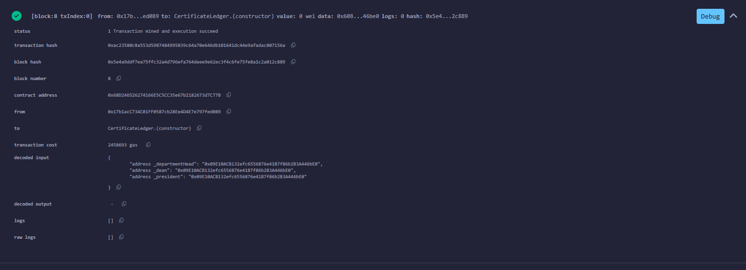

3 Transaction details
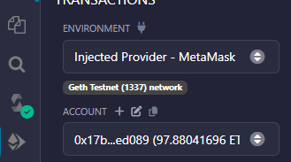

ganache
1 all accounts
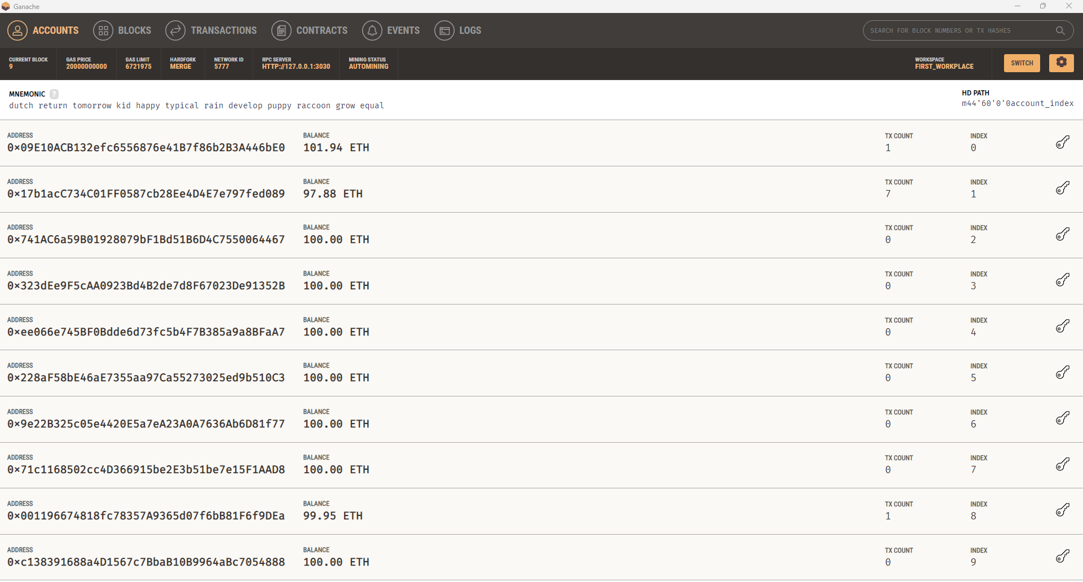
2 block of creation
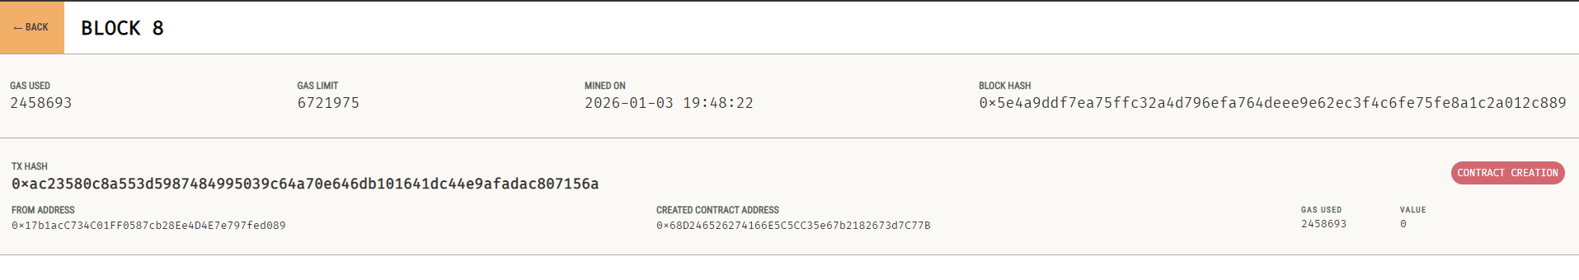
3 block of first payment
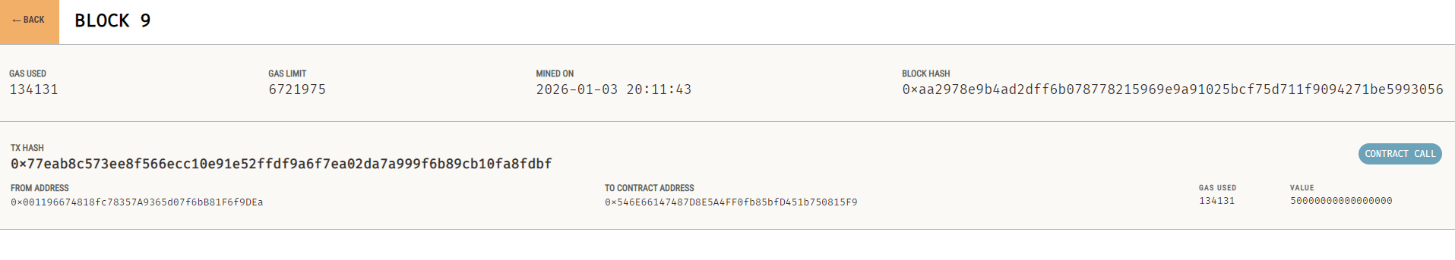

MetaMask
1 accounts
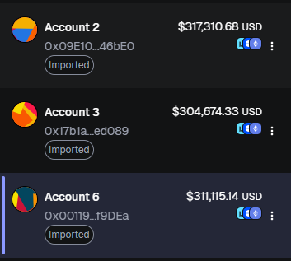
2 contract publishing payment
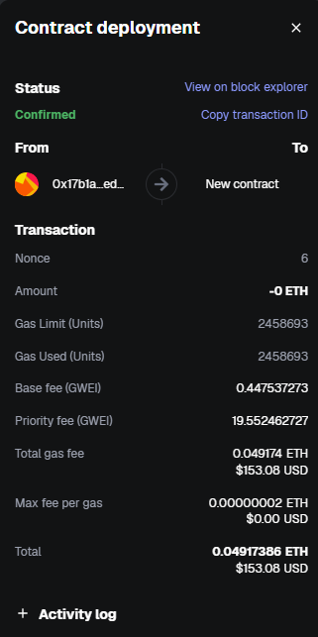
3 first transaction
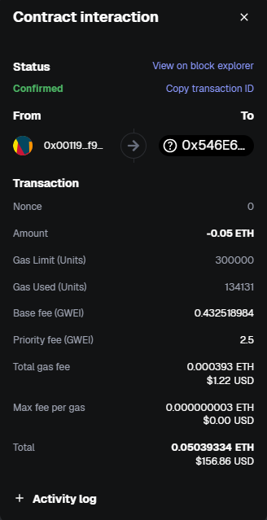

UI
1 Owner/admin
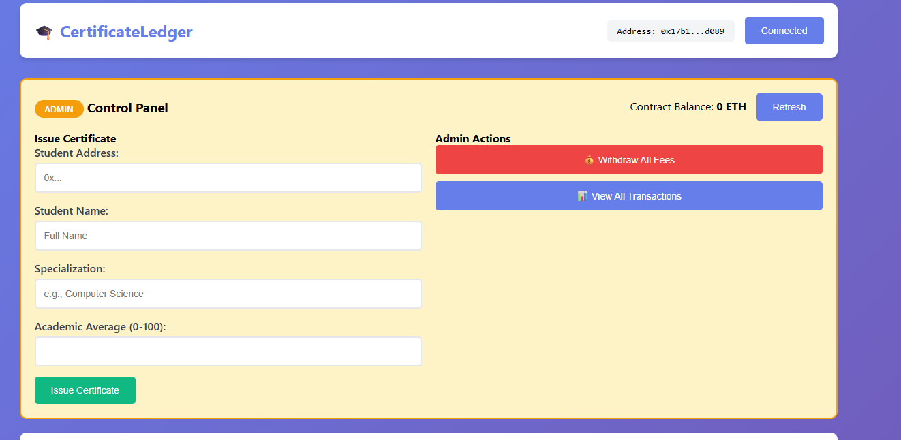

2 Students
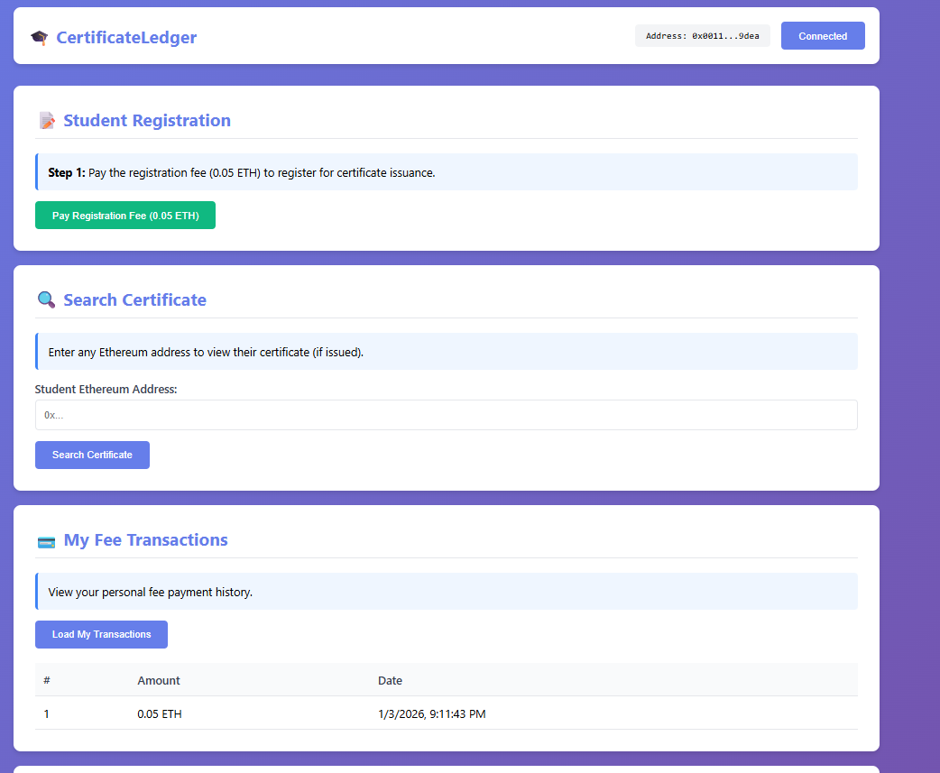

Reference list
The provided slides
https://hedera.com/learning/proof-of-stake-vs-proof-of-work/#:~:text=Each%20is%20used%20to%20validate,it%20in%20very%20different%20ways.
https://www.morpher.com/blog/pow-vs-pos-comparison#:~:text=What%20is%20the%20difference%20between,and%20faster%20transaction%20confirmation%20times.
https://gdpr-info.eu/art-17-gdpr/
https://coinmarketcap.com/academy/glossary/ring-signature

